Central Lincolnshire

Housing and Economic Land Availability Assessment

March 2020

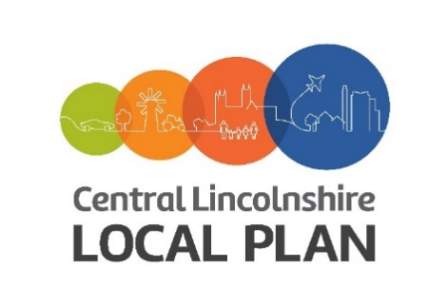

Contents

1.0 Introduction 3
2.0 National Policy Context 3
3.0 Local Policy Context 4
4.0 Methodology 4
5.0 Conclusion 9

Appendices
A Datasets used for constraint check
B Sites submitted that do not meet the threshold
C Site Assessment Details – City of Lincoln
D Sites Assessment Details – North Kesteven District
E Site Assessment Details – West Lindsey District

(Please note appendices C, D and E are separate to this document)

Introduction

  - The National Planning Policy Framework (NPPF) sets out a requirement for Local Authorities to maintain an adequate supply of housing sites in their area. The Planning Practice Guidance (PPG) identifies a methodology for carrying out a Housing and Economic Land Availability Assessment (HELAA) which is the technical study that provides the evidence base in order to assess land availability for suitable, available and achievable sites for housing and economic development. The HELAA ‘is an important source of evidence to inform plan-making and decision-taking, and the identification of a 5-year supply of housing land’.

  - It is important to note that the HELAA is a technical study and its role is to provide information on a range of sites, including the suitability, availability and achievability of land for development. The HELAA does not determine which sites should be allocated through the Local Plan but it does provide an important evidence base about a wide range of sites. The HELAA does not alter any existing policies or designations and is not a statement of policy. The HELAA assessment is based on an objective and consistent methodology which seeks to capture information on constraints as they are at a certain point in time.

National Policy Context
  - The NPPF underwent substantial revision and was published in July 2018 (with further minor updates in February 2019) and continues to set out the Government’s planning policy framework for England. The delivery of sustainable development and the three overarching objectives of economic, social and environmental factors remains at the heart of national planning policy.

  - The preparation of an evidence base to identify an up to date land supply in order to inform the development of the local plan is required in the NPPF. Paragraph 67 of the NPPF sets out that ‘strategic policy making authorities should have a clear understanding of the land available in their area through the preparation of a strategic housing land availability assessment’.

  - In order to assist in interpreting and applying the NPPF, the Government produced the Planning Practice Guidance (PPG) in 2014 and provides a live source of guidance updated regularly by Government. The PPG identifies that ‘plan-making authorities may carry out land availability assessments for housing and economic development as part of the same exercise, in order that sites may be identified for the use(s) which is most appropriate’. All sites are included in the Central Lincolnshire HELAA March 2020, regardless of what use they have been promoted for by the landowner/ agent.

Local Policy Context

  - The first Central Lincolnshire Local Plan was adopted in April 2017. Central Lincolnshire is a joint planning unit responsible for plan making across three local authority areas, including City of Lincoln Council, North Kesteven District Council and West Lindsey District Council.

  - In January 2019 the decision was taken to review the adopted Local Plan in order to respond to the changes published in the revised NPPF in July 2018 and to address land supply in Central Lincolnshire.

  - The last assessment of land supply (SHLAA) was published in July 2015 and was a key piece of evidence that informed the preparation of the current 2017 Local Plan. This HELAA has been prepared to revisit the sites identified in 2015 to make sure that only sites that are available and are being actively promoted through the HELAA process are included moving forward.

  - Owners and promoters of sites that were in the Central Lincolnshire sites database were consulted between February and March 2019 with a new site suggestion form to confirm the ongoing suitability and availability of their sites for development. The form sent out requested a wide range of information including details about the deliverability of sites. An interactive map was provided on the Central Lincolnshire Local Plan website where those contacted could review the site boundary held on file and any corrections or amendments needed could be flagged and resolved. This consultation process has enabled a clear and up to date assessment to take place. Responses were received on 440 sites and these sites are included in this assessment.

  - A call for sites was carried out in June 2019 to allow for new sites to be put forward and added to the sites database. This report contains the new sites together with those previously contained within the June 2019 report, providing the most up to date evidence base on land supply for a total of 705 sites. This will in turn inform the site allocation assessment process as part of the Local Plan review. The site allocation assessment process will use the HELAA as the source of sites to be assessed and the constraints identified, but will also balance other evidence and information in the decision making process.

Methodology

  - The methodology used for this HELAA is based on the approach identified in the PPG. The PPG sets out a flow chart (below) on identifying each step of the process to be followed.

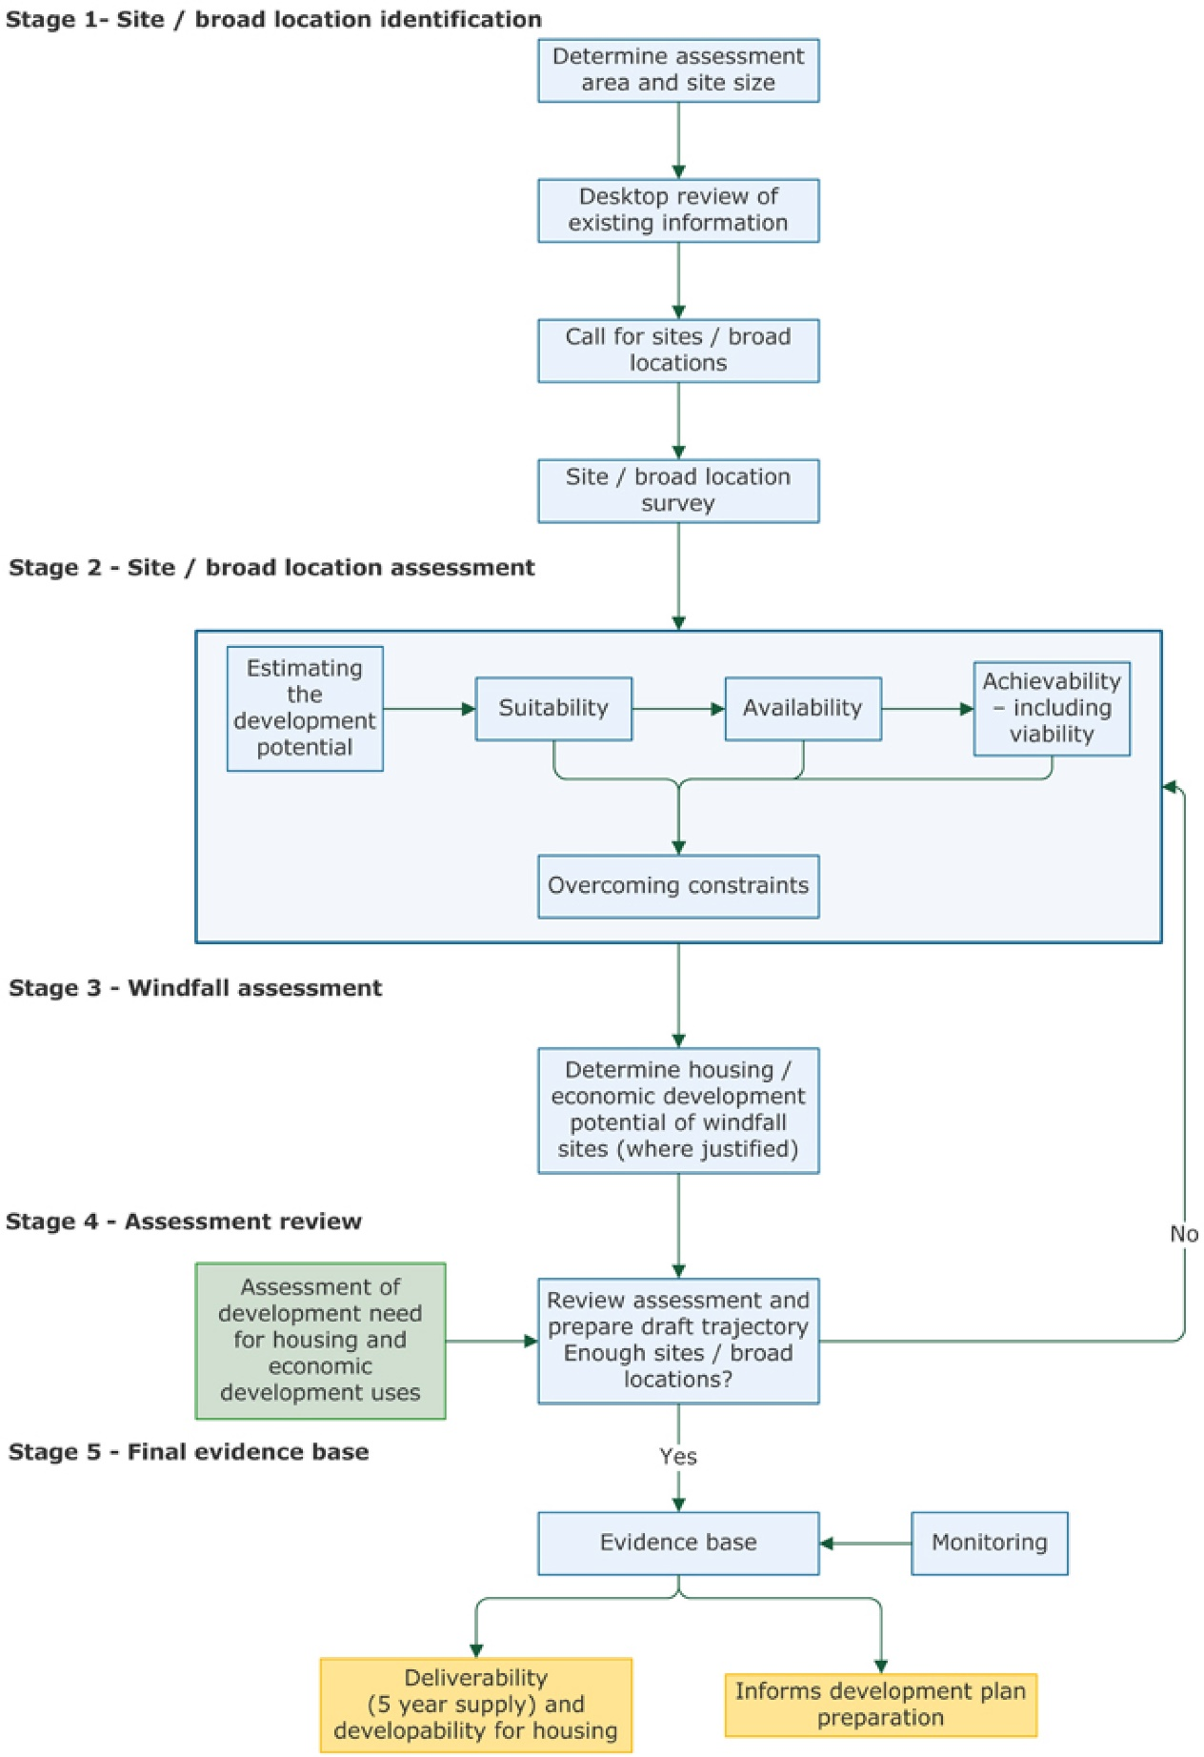

Stage 1 – Site/ Broad location identification
  - In order to assess the land that is potentially available and suitable for housing and economic development, it is first necessary to identify the potential land opportunities that exist. The HELAA considers a range of different site sizes from small scale to large scale sites such as sustainable urban extensions. It is therefore important to identify the geographical area which is to be looked at for available land and the threshold of sites to be included.

  - The geographical scope of the assessment is the three local authority areas that make up the Central Lincolnshire area, including City of Lincoln Council, North Kesteven District Council and West Lindsey District Council.

  - The PPG states that ‘plan-makers will need to assess a range of different site sizes from small-scale sites to opportunities for large-scale developments such as village and town extensions and new settlements where appropriate’. A threshold of sites capable of delivering 5 or more dwellings or economic development on sites of 0.25ha (or 500m² of floor space) and above is identified in the guidance.

  - This HELAA includes all sites that meet this threshold and all of these sites are identified in Appendix C, D and E, along with a data sheet, a site location plan, constraint information and details about availability and achievability. All sites have been identified with a unique reference number which is made up of the district code, parish or ward code and then a 3 digit number. All sites that were submitted but do not meet the size threshold have been identified and are listed in Appendix B. Site suggestion forms were received for 705 sites, with 682 of those sites meeting the threshold.

  - A wide range of information, including for example, environmental, landscape and heritage constraints have been collated in order to complete a desktop review of each site. This data was accurate at September 2019. Details of the sources of data collated for each site is identified in Appendix A.

  - As part of the consultation on the sites in the database during February and March 2019 and the request for a new site suggestion form to be provided for each site, up to date information has been collated on the availability and achievability of each site.

  - A call for sites was carried out in June 2019 when a range of different stakeholders were contacted requesting that any available sites were put forward. The range of stakeholders included agents, developers, local authorities, the county council, parish councils, neighbourhood planning groups and other consultees identified on the consultation database. The call for sites was also advertised on the Central Lincolnshire Local Plan website. Any additional sites promoted have been added to the sites database.
4.8 Following the call for sites in June 2019, all sites that meet the threshold criteria for allocation in the Local Plan were surveyed.

Stage 2 – Site/ Broad Location Assessment
  - The purpose of this stage of the process is to determine whether sites are suitable or not for development, and whether they are available and achievable, consistent with national definitions.

Calculating Development Potential
  - The housing potential of a site refers to the net number of dwellings that a site can accommodate through its development or conversion of existing buildings. Rather than make a standard assumption of 30 dwellings per hectare across the whole of the three local authority areas, an analysis of recent schemes, which have a recent planning permission in place or are actively under construction has been used to identify densities across the various different settlement location types. Further detail on this can be found in the Site Allocation Assessment Methodology Consultation Paper June 2019, which is available at www.central-lincs.org.uk.
4.11 The amount of a site which can be developed, when taking into account the requirement for other types of infrastructure, is also an important factor. Typically the larger the site, the less of the site is actually available for the development of housing when roads, open spaces, schools and other infrastructure are factored in. Once the developable area has been calculated, a density assumption based on the location of the site is applied. The following assumptions in tables 1 and 2 below are therefore used in identifying an indicative capacity for each of the sites.
Table 1: Developable Area of Sites
Site Size | Percentage of the site developable
Less than 0.4 hectares | 100%
0.4 – 2 hectares | 85%
2 – 10 hectares | 75%
10 hectares or larger | 60%

Table 2: Site Capacity Assumptions
Settlement Hierarchy Category | Density Assumption (dwellings per hectare)
Lincoln City Centre (within 1km of railway station) | 90 dph
Wider Lincoln Urban Area | 40 dph
Town centres | 50 dph
Town suburbs | 35 dph
Villages | 30 dph

Assessing Suitability
  - As part of the site allocation assessment, the location of each site will be assessed to identify whether it is in an appropriate location to contribute to sustainable development. Once this has been identified, the constraints identified during the desktop review, along with the site survey will be used to assess the suitability of a site. Physical limitations of a site such as issues with accessing the site, the utilities available, ground conditions, potential contamination, hazardous risks and flood risk will all be taken into account. Following on from any physical constraints, potential impacts on heritage assets, the landscape, local and national wildlife sites will be assessed. The potential for a site to contribute to the regeneration of an area will also be considered in the assessment for how suitable a site is for development.

Assessing Availability
  - The PPG considers a site to be ‘available’ for development when, on the best information available, there is confidence that there are no legal or ownership impediments to development. Sites meeting the definition of deliverable should be considered available unless evidence indicates otherwise. All sites that have been included have been suggested by landowners, planning agents on behalf of landowners or developers who have an interest in the site. Confirmation as to whether the site is in multiple ownership or single ownership has also been sought. Timescales of when a site will be available and for what use the site is being promoted for has also be identified for each site. This information will be used to assess the availability of a site.

Assessing Achievability
  - For a site to be considered achievable, and therefore deliverable, there should be a ‘reasonable’ prospect that the particular type of development will be developed on the site at a particular point in time. This is a judgement about the economic viability of the site and the capacity of the developer to complete and let or sell the development over a certain period. Details of viability were requested on the site suggestion form and confirmation as to whether a viability assessment has been completed or not and the outcome of that assessment. This information is identified for each site and will be used to assess the achievability of a site.

Overcoming Constraints
  - Where constraints are identified through the assessments of suitability, availability and achievability, consideration needs to be given to what is needed to overcome them. In the assessment of sites being considered for allocation, consideration will be given to what intervention or mitigation may be required to bring forward a site, such as whether there is a need for new infrastructure, equalisation agreements or specific design solutions for example, and this will be taken into account in the full assessment of a site.

Stage 3 – Windfall Assessment
  - The NPPF and PPG identify that a windfall allowance may be justified in the five year supply of land if there is compelling evidence that they will provide a reliable source of supply. The assessment of the contribution that windfall developments make to the land supply across Central Lincolnshire is identified and presented annually in the Five Year Land Supply Report which is available at www.central-lincs.org.uk.

Stage 4 – Assessment Review
  - The PPG identifies that once all the sites have been assessed, an indicative trajectory should be produced to identify how much housing and economic development can be provided and at what point in the future. Once the assessment of each site through stages 1 to 3 of the process is completed, the development potential of sites that are considered suitable, available and achievable will be identified and set out.

Stage 5 – Evidence Base
  - This HELAA report identifies the sites that are available within Central Lincolnshire at this point in time. It provides the starting point of an evidence base of sites that can be taken through the site allocation assessment methodology to complete a full assessment of the suitability, availability and achievability of each site.

5.0 Conclusion

5.1 This HELAA includes all sites with a threshold of 5 dwellings or more or 0.25 ha of employment land (or 500m² floor area) that are known to the Central Lincolnshire Local Plan Team as available for development. A robust cleanse of the HELAA database during February and March 2019 has provided an up to date position on the current status of the sites identified in terms of their availability and achievability. A desktop constraint check has been completed with current datasets. A unique reference number based on the district and ward/parish is provided for each site and a site location plan accompanies each site on the data sheets identified in Appendix C. Of the 705 site suggestion forms received, 682 sites met the threshold and have been included in the assessment. The HELAA provides an evidence base of sites that are available for development which can be carried forward and assessed through the site allocations assessment process.
5.2 It is important to remember that inclusion of sites in this HELAA does not confirm that sites are suitable to come forward for development. Decisions on which sites will be taken forward for allocation will be made through the Local Plan process.

Appendices

Appendix A
Datasets used for Constraint Check

Dataset | Source
Flood Risk Zone 2 | Environment Agency
Flood Risk Zone 3
Surface Water Flooding High Risk
Surface Water Flooding Medium Risk
SSSI | Natural England
Nature Improvement Areas (NIA)
National Nature Reserves (NNR)
Special Protection Areas (SPA)
Special Area of Conservation (SAC)
Ramsar
Agricultural Land Classification
Local Nature Reserves (LNR)
Ancient Woodland
Area of Outstanding Natural Beauty (AONB)
Local Wildlife Sites (LWS) | Greater Lincolnshire Nature Partnership
Sites of Nature Conservation Interest (SNCI)
Local Geological Sites
TPO | Local Authority Datasets
Air Quality Management Area
Conservation Areas
High Pressure Pipelines
Greed Wedge | Local Plan Datasets
Area of Great Landscape Value
Protected Local Green Space
Scheduled Ancient Monument (SAM) | Historic England
Listed Buildings
Historic Parks & Gardens
Hazardous Sites | HSE
Minerals and Waste Safeguarding | Lincolnshire County Council Minerals and Waste Local Plan

Appendix B: Sites submitted that do not meet the threshold
Reference | Easting | Northing | Site Address | Settlement Hierarchy Adopted Local Plan 2017 | Site Capacity
CLNEW014 | 513453 | 392640 | Land opposite Kestrels, Otby Lane, Walesby | Small Villages | 1
CL1940 | 516062 | 409870 | Rear of 1 Mill Lane, Keelby | Large Villages | 1
CL1950 | 504454 | 401843 | Rose Cottage, High Street, North Kelsey | Medium Villages | 2
CL129 | 505931 | 348900 | 7 Wansbeck Road , Leasingham | Medium Villages | 2
CL1949 | 504211 | 402002 | Land South of Bridge Willow, North Kelsey | Medium Villages | 2
CL810 | 496611 | 373717 | 367A Burton Road | Lincoln Urban Area | 2
CLNEW010 | 513347 | 392332 | Land between Graycroft and Pantiles, Rasen Road, Walesby | Small Villages | 2
CL1406 | 507226 | 392789 | Main Street, Osgodby | Small Villages | 2
CLNEW012 | 513478 | 392614 | Land to the south of Kestrels, Otby Lane, Walesby | Small Villages | 2
CLNEW011 | 513324 | 392363 | Land between Wychaway and Beech Cottage, Moor Road, Walesby | Small Villages | 2
CL4062 | 515281 | 399713 | Land at 17 Partridge Drive, Rothwell, Market Rasen | Small Villages | 3
CL3019 | 505609 | 366817 | 8 Moor Lane, Potterhanworth, LN4 2DZ | Medium Villages | 3
CL3013 | 490734 | 365690 | Land off Lincoln Lane, Holme Farm, Thorpe on the Hill | Small Villages | 3
CL902 | 507301 | 361470 | Site at 7/9 Station Road, Metheringham | Large Villages | 3
CL342 | 492582 | 371952 | Land adjacent to 2 Lower Church Road, Skellingthorpe, Lincoln, LN6 5UZ | Large Villages | 3
CL1629 | 481408 | 390257 | The Fanny Marshall Institute, 49 Church Street, Gainsborough, DN21 2JX | Main Towns | 3
CL4066 | 510305 | 401729 | Land at Sports Pavillion, Moor Lane, Caistor, Market Rasen | Countryside | 4
CL846 | 506865 | 359979 | Stable Block off B1188, Blankney | Countryside | 4
CL1902 | 503262 | 376058 | The Sonnets, Sudbrooke | Medium Villages | 4
N/A | 504373 | 401539 | Land at Green Lane, North Kelsey | Medium Villages | 2
NK/MART/006 |  |  | Land to the west of Linwood Road, north of Mrs Mary Kings Primary School, Martin | Medium Villages | 4
NK/TOTH/007 |  |  | Land between 24 and 30 Lincoln Lane, Thorpe on the Hill | Small Villages | 3
WL/BUR/003 |  |  | Land adjacent Hillside Cottages, Main Street, Burton | Small Villages | 3
WL/NOT/002 |  |  | Land west of A1133, north of Timber Yard, Newton on Trent | Small Villages | 4

(Please note Appendices C, D and E are separate to this report)

Paragraph 67 – National Planning Policy Framework 2018
Paragraph: 001 Ref: ID: 3-001-20190722 - Planning Practice Guidance
Paragraph: 001 Ref: ID: 3-001-20190722 - Planning Practice Guidance
Paragraph: 005 Reference ID: 3-005-20190722 – Planning Practice Guidance
Paragraph: 009 Reference ID: 3-009-20190722 – Planning Practice Guidance
Paragraph: 019 Reference ID: 3-019-20190722 – Planning Practice Guidance
Paragraph: 020 Reference ID: 3-020-20190722 – Planning Practice Guidance
Paragraph 70 – NPPF; Paragraph: 23 Reference ID: 3-023-20190722 – Planning Practice Guidance

